**Job Application Tracker System**

**TABLE OF CONTENTS**

**1.** **SYSTEM ARCHITECTURE**

**2.** **UML DIAGRAMS**

1.1.1. Use Case Diagram

1.1.2. Sequence Diagram

1.1.3. Class Diagram

1.1.4. Component Diagram

1.1.5. Deployment Diagram

1. **SYSTEM ARCHITECTURE**
2. **UML DIAGRAMS**

1.1.1 Use Case Diagram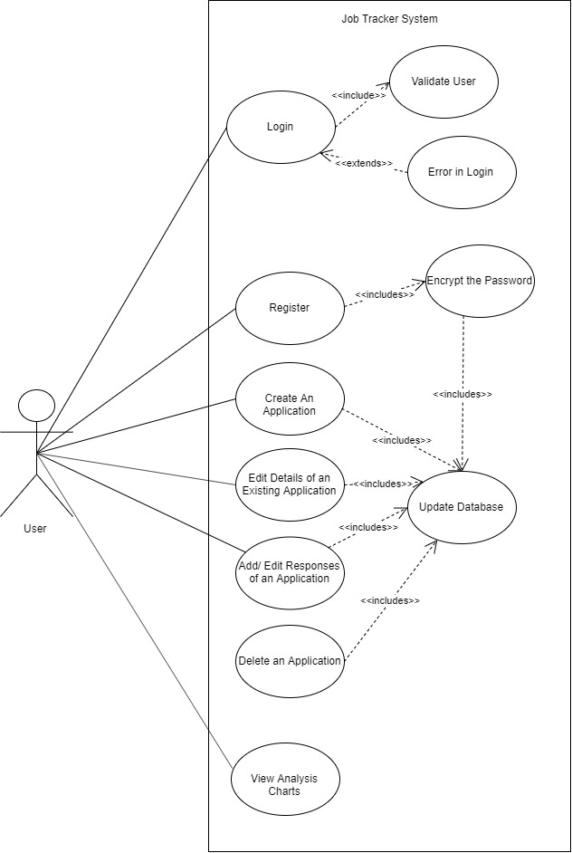

1.1.2 Sequence Diagram

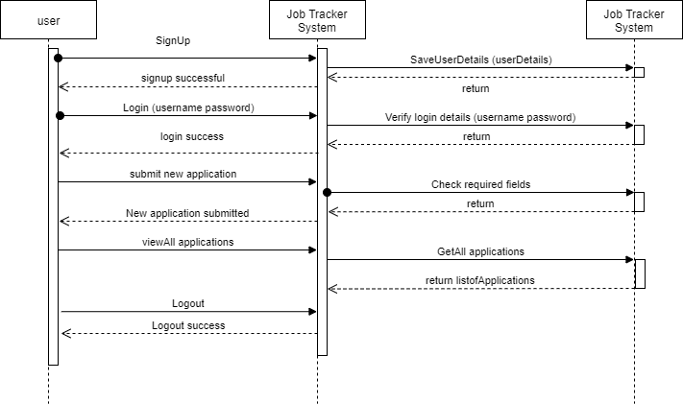

1.1.3 Class Diagram

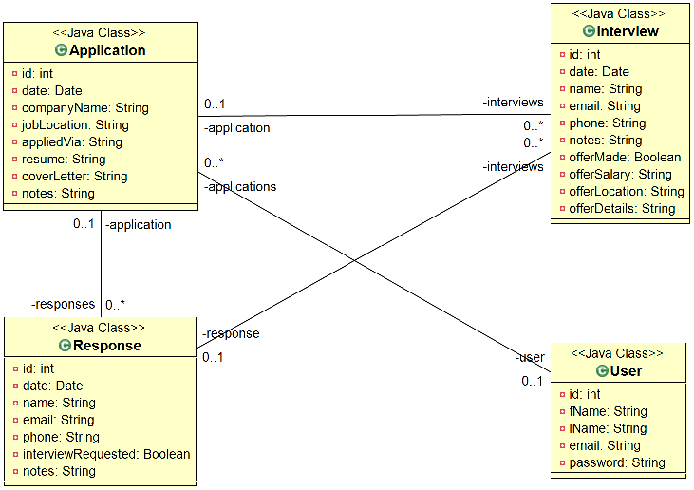

1.1.4 Component Diagram

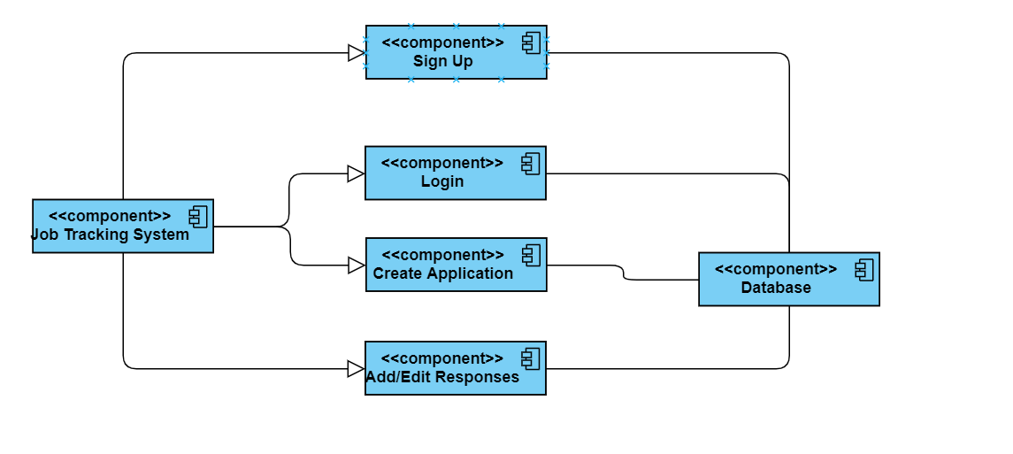

1.1.5 Deployment Diagram

